Mountain of Fire and Miracles Ministries
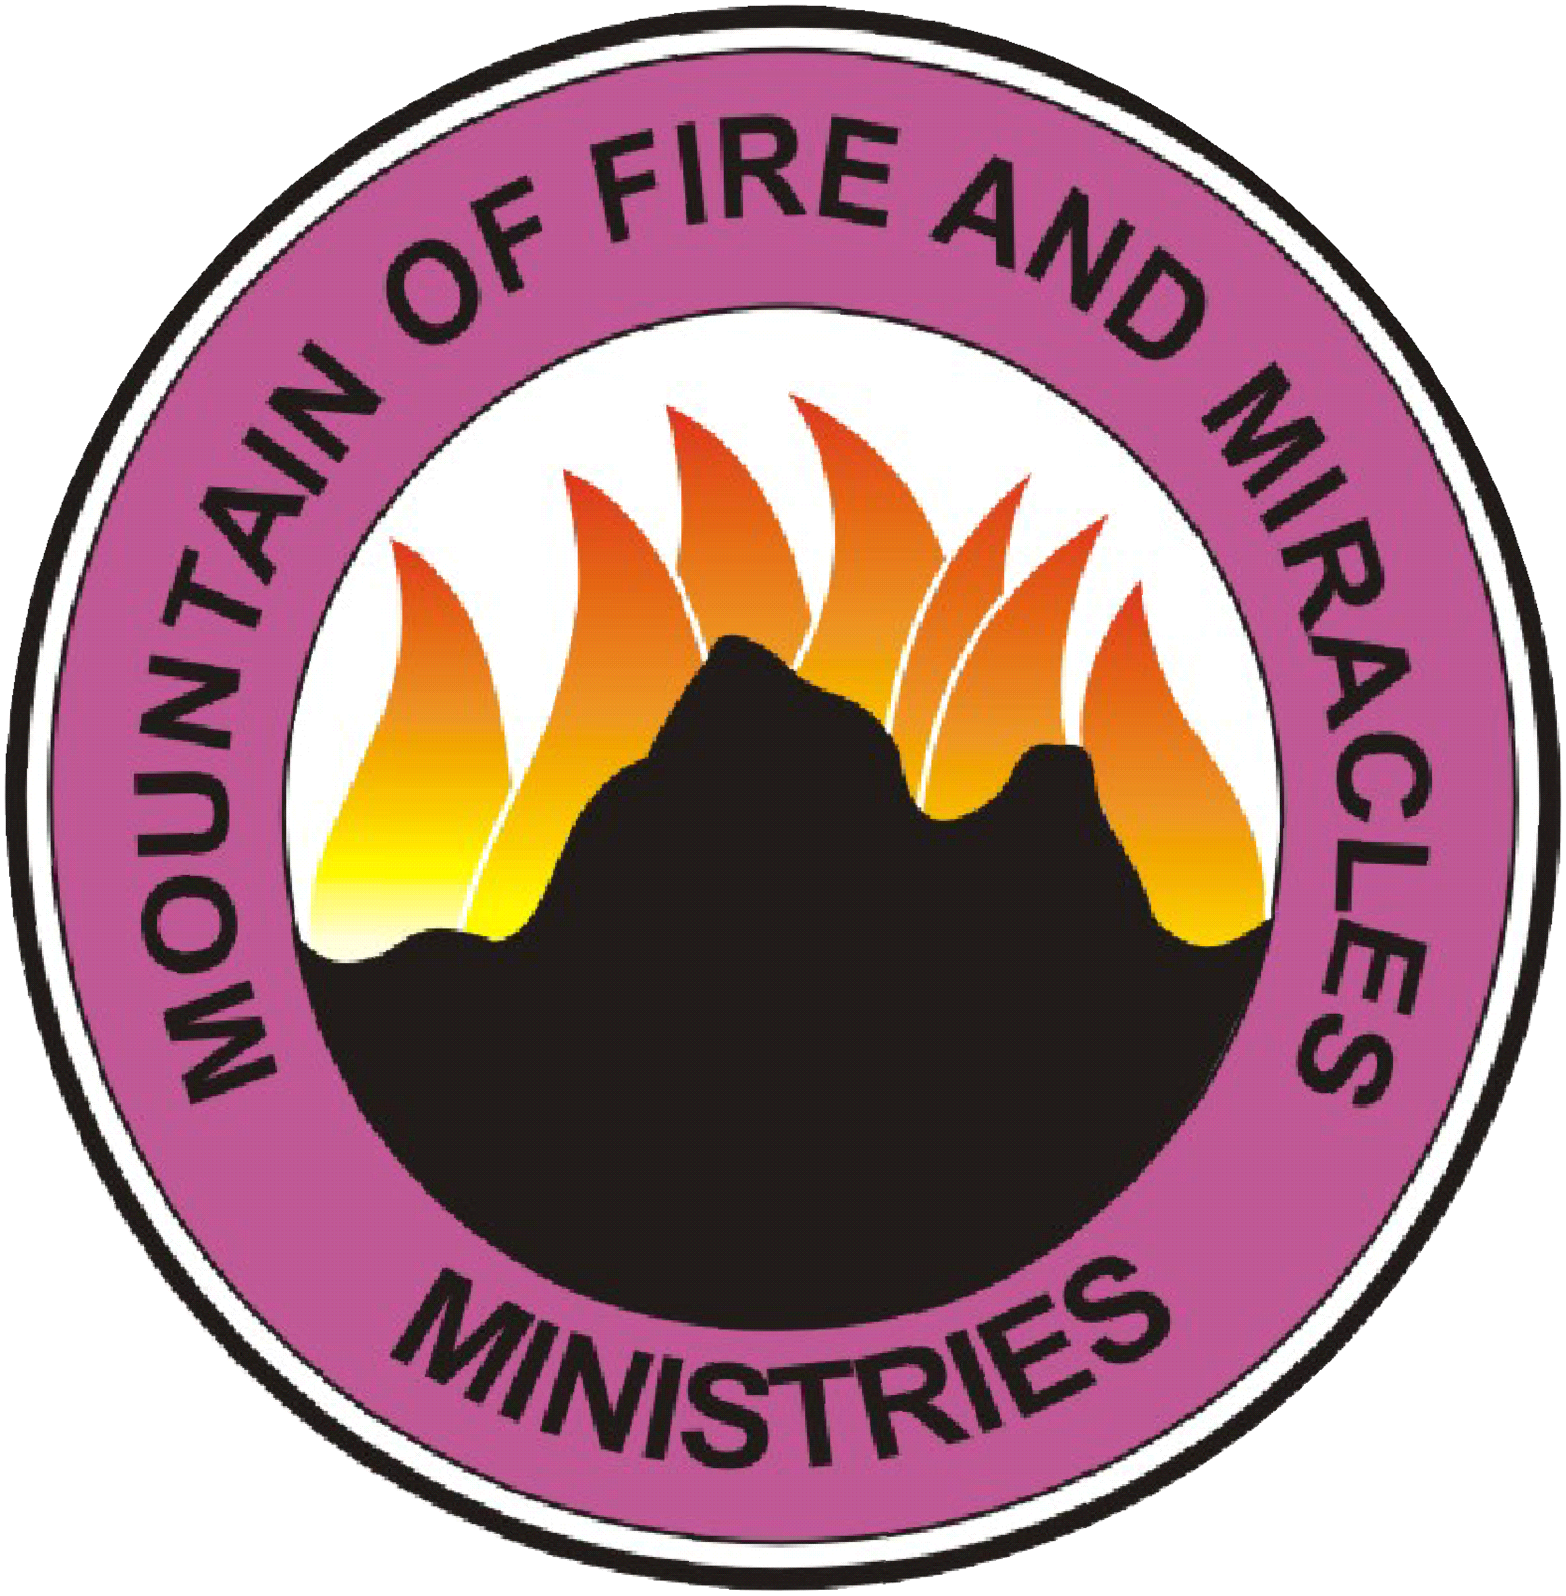
Revival Chapel
16211 Clay Rd. Ste. 114 Houston TX 77084
REVOKING EVIL VERDICT
Confession: Psalm 33:18-19; 118:17
Aggressive Worship
1. Thou power of resurrection locate every department of my life, in the name of Jesus.
2. I put myself in the envelope of blood of Jesus.
3. Every witchcraft burial of my destiny, I cancel you by fire, in the name of Jesus.
4. Every witchcraft burial of my spiritual life, I cancel you by fire, in the name of Jesus.
5. Every witchcraft burial of my health, I cancel you by fire, in the name of Jesus.
6. Every witchcraft burial of my peace, I cancel you by fire, in the name of Jesus.
7. Every witchcraft burial of my wealth, I cancel you by fire, in the name of Jesus.
8. Every witchcraft burial of my marriage, I cancel you by fire, in the name of Jesus.
9. Every evil summoning of my name in any witchcraft coven, backfire, in the name of Jesus. 10. Every pronouncement of death upon my life, die, in the name of Jesus.
11. Every seed of untimely death in my family life, release me and die, in the name of Jesus.
12. Evil pattern of untimely death in my family line, release me and break, in the name of Jesus.
13. Every spirit of tragedy in my family line, I am not your candidate, die, in the name of Jesus.
14. Every power announcing my name f or death, fall down and die, in the name of Jesus.
15. Every agenda of untimely death for my life, backfire, in the name of Jesus.
16. Every food of death that I have consumed, be roasted, in the name of Jesus.
17. I refuse to inhale the wind of death, in the name of Jesus.
18. Every grave dug for my life, swallow your digger, in the name of Jesus.
19. Every coffin constructed for my life, catch your owner, in the name of Jesus.
20. Every dream of untimely death, die, in the name of Jesus.
21. Every sickness unto death, loose your hold upon my life, in the name of Jesus.
22. Every gunshot in the dream, be neutralized by the blood of Jesus.
23. Every good thing that is dead in my life, receive life by fire, in the name of Jesus.
24. Any part of my body under any oppression, receive deliverance, in the name of Jesus.
25. Every power planning tragedy and calamity for my life, fall down and die, in the name of Jesus.
26. Anything representing me on any evil altar for untimely death, catch fire now, in the name of Jesus.
27. Any power using my life to renew his life, fall down and die, in the name of Jesus.in the name of Jesus.
28. Every bitter water flowing in my family from any idol, dry up, in the name of Jesus.
29. Any rope tying my family line to any family idol break, in the name of Jesus.
30. Every landlord spirit troubling my destiny, be paralysed, in the name of Jesus.

